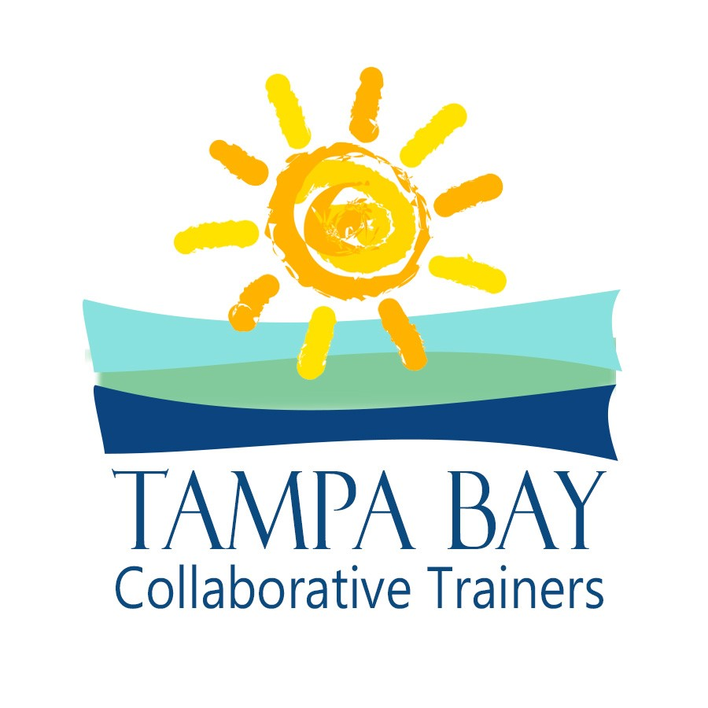

412 East Madison Street, Suite 824
Tampa, Florida 33602

813.443.0615 (T)
813.489.4567 (F)
adam@cordoverlaw.com

PROPOSAL
TAMPA BAY COLLABORATIVE TRAINERS

Adam B. Cordover, J.D., M.A.
Kristin E. DiMeo, CPA, ABV
Jeremy S. Gaies, Psy.D.
Barbara E. Kelly, Ph.D.
J. David Harper, CPA, ABV, PFS, CFF, CBA, CVA

Http://TampaBayCollaborativeTrainers.com

Proposal to Provide
Introductory Collaborative Training
For ______________________
_______________, 20______

Our Mission: To provide attorneys, mental health professionals, financial professionals, mediators, and others the real world tools to help clients via the Collaborative Process in concert with the practices and standards of your local community.

How We Stand Out: Tampa Bay Collaborative Trainers offer an engaging, customized two-day introductory interdisciplinary training in the neutral facilitator/neutral mental health professional model at a low-risk cost structure that will help you build a vibrant collaborative community.

Our Values: We value pride in collaborative work, and practicality in skill-building. We value input from local practice groups and customization to meet local procedures. We value the introduction of new ideas, along with a commitment to excellence. We value open, honest, and respectful communications. We value self-determination. We value team work, efficiency, clear boundaries, and creativity. We value fiscal responsibility and appropriate allocation of risk.
We value the growth of a thriving collaborative community. Tampa Bay and Greater Sarasota are home to four collaborative practice groups. There are more affiliated collaborative practitioners in the Greater Tampa Bay area than in any other metropolitan location in the state of Florida. We strive to share the lessons that we have learned in developing a vibrant collaborative community with other locales.

Tampa Bay Collaborative Trainers (“TRAINING TEAM”) offer an introductory Collaborative Practice training that meets or exceeds the Interim Minimum Standards for Introductory Interdisciplinary Collaborative Practice Trainings (approved October 2014) of the International Academy of Collaborative Professional (IACP). Each TRAINING TEAM trainer meets and exceeds the IACP Interim Minimum Standards for Collaborative Trainers (approved October 2014; clarified February 2015). TRAINING TEAM is pleased to submit this proposal to provide training in _______, ___ 20___ (or another date as agreed upon in writing by the TRAINING TEAM) in the _____________ area sponsored by _________________________ (“Host”).
Trainers
TRAINING TEAM trainers are a group of professional trainers who have been instrumental in building the local collaborative community and who are passionate about helping other communities do the same. The TRAINING TEAM trainers consist of the following:

- Adam B. Cordover, J.D., M.A., is a collaborative attorney, trainer, and Florida Supreme Court Certified Family Law Mediator who practices exclusively in private dispute resolution in Tampa, Florida. Adam is the Immediate Past President of Next Generation Divorce, Florida’s largest collaborative practice group. Adam is co-author with Forrest (Woody) Mosten of an upcoming American Bar Association Book on “Building A Successful Collaborative Law Practice.”
- Kristin E. DiMeo, CPA, ABV, has served as the Financial Neutral in over 75 collaborative family law matters in the Tampa Bay area. She is the immediate past Co-Chair of the Tampa Bay Academy of Collaborative Professionals (f/k/a Tampa Bay Collaborative Divorce Group), past Co-Chair of the Collaborative Law Section of the Hillsborough County Bar Association and is a member of Next Generation Divorce.
- Jeremy S. Gaies, Psy.D., is a licensed psychologist and certified family mediator who specializes in helping divorcing families pursue peaceful solutions through his work in parenting coordination and collaborative divorce. Dr. Gaies has participated in multiple local, state, and international committees advancing the collaborative movement. He is actively involved in two practice groups: Tampa Bay Academy of Collaborative Professionals and Next Generation Divorce. Dr. Gaies is also the co-author of “Mindful Co-Parenting: A Child-Friendly Path Through Divorce.”
- Barbara E. Kelly, Ph.D., is a licensed psychologist and certified family mediator who has been working in the collaborative model for the past ten years. She brings her experience with the international collaborative community and working with interdisciplinary collaborative teams to her training of other collaborative practitioners. She has provided introductory and advanced collaborative trainings locally, nationally, and internationally.
- David Harper, CPA, ABV, PFS, CFF, CBA, CVA is a leading member of Next Generation Divorce and Tampa Bay Academy of Collaborative Professionals and contributing author for Adam Cordover’s and Forrest (Woody) Mosten’s upcoming book “Building a Profitable & Successful Collaborative Law Practice.” He has extensive experience serving as financial neutral in collaborative divorce matters as well as joint expert in other family law cases and has presented on a wide range of financial topics including collaborative law, family law financial procedures, business valuation and executive compensation.

TRAINING TEAM agrees to provide trainers, typically at least one from each discipline (one attorney, one mental health professional, and one financial professional), and conduct an Introductory Collaborative Practice Training that meets IACP standards as generally described above.

TRAINING TEAM trainers each warrant that he/she meets the Interim Minimum Standards for Collaborative Trainers (approved October 2014; clarified February 2015).

Program Overview
Attached please find the Agenda for the TRAINING TEAM’S program as typically presented. This curriculum was developed using the IACP Standards for Introductory Interdisciplinary Collaborative Training.
TRAINING TEAM understands that the Host organization may want to modify this agenda to meet the needs of the local community. TRAINING TEAM is open to discussing proposed changes to customize the training experience and to incorporating suggestions of our Host organization to the greatest extent possible, while still meeting the IACP Standards.

Proposal Details
Location, Dates and Times
As soon as practicable, TRAINING TEAM and Host will agree on a date and time for the training so that schedules can be finalized. The Host will be responsible for securing presentation space on the dates designated for training. Training times will be 8:00 a.m. to 5:00 p.m. (with one hour for lunch) on the first day and 8:00 a.m. to 5:00 p.m. (with one hour for lunch) on the second day. The attached agenda outlines registration times and breaks. TRAINING TEAM suggests that the Host organize a happy hour or dinner for attendees after training on the first day, and the TRAINING TEAM is open to a dinner with the Board or other leaders of the Host in early evening the day prior to the first day of training.
In addition, TRAINING TEAM requests that they meet with at least one representative of the Host organization in the presentation space on the evening before the first day for one to two hours. This meeting will allow for an A/V equipment check, to finalize the numbers and professions of attendees, to review printed material, etc. The meeting space should be secured following that meeting so that TRAINING TEAM’s materials can be left in the training space overnight. The training space will be made available to TRAINING TEAM at 7:00 am the morning of the first day.

Roles, Responsibility and Milestones
Host Responsibility Checklist: With this proposal, you will find a Host Responsibility Checklist that outlines what will be expected from the HOST. You can also find further explanation below.
Phase One: From the date of agreement to the 45th day prior to training.
Host has secured a venue for the anticipated number of attendees and will communicate the set-up of the chosen facility to TRAINING TEAM. The venue is to have audio/visual equipment installed that allows for the projection of Power Point presentations and DVDs. No later than 60 days prior to the training, TRAINING TEAM will provide Host a pre-training questionnaire regarding local practices. This will allow TRAINING TEAM to mold its curriculum to meet the local community’s needs.
As part of the preparation for training, TRAINING TEAM requests that Host conduct no less than 2 hours and up to 8 hours of telephone and/or in person communication to help assess the unique characteristics of the LOCATION’s community and tailor role plays to unique challenges of that community. The Host will designate one local contact professional with whom the TRAINING TEAM will interact regarding logistics and curriculum.

Phase Two: Forty-five days to the day prior to training
At regular intervals prior to the first day of training (45 days, 30 days, 15 days, 7 days, 2 days) Host and TRAINING TEAM shall communicate to confirm planning for a successful training experience. Host will also provide TRAINING TEAM with a list of registrants that includes names, profession, city & state, and e-mail addresses. TRAINING TEAM will design and provide an Interdisciplinary Collaborative Practice Introductory Training Manual, which the Host may choose to print out for attendees or send to attendees as a PDF to view on electronic devices. If a decision is made that attendees should view manuals on electronic devices, the Host will ensure that accommodations include a sufficient number of outlets and power strips.
The manual will be delivered to Host in electronic format no later than 14 days prior to the beginning of training. Host is responsible for covering the costs of printing the manual (if applicable) and any other items requested by the TRAINING TEAM including the agenda, handouts, attendee list, and other key materials as identified by TRAINING TEAM. If the full manual is printed, Host will bind or place the materials in three ring binders with tabs and/or section dividers. Host is not authorized to make changes to the manual, other than for the reproduction of the manual or to add sponsorship pages, without written permission from TRAINING TEAM.

Phase Three: Training days

TRAINING TEAM agrees to provide trainers, typically at least one from each discipline (one attorney, one mental health professional, and one mental health professional), and conduct an Introductory Collaborative Practice Training that meets IACP standards as generally described above.
Host agrees to manage all registration and attendance functions and to provide at least two local professionals to assist with greeting and signing-in participants, and 3 professionals playing the roles of an attorney and the two spouses during demonstrations and answering participants’ jurisdiction-specific questions.
Host agrees to collect training evaluation forms and secure and pay for any continuing educational credits for the various disciplines.

Phase Four:
Within 10 days of the conclusion of the training, Host agrees to forward copies of the evaluation forms to TRAINING TEAM. TRAINING TEAM requests that a representation of the Host organization be available for at least one thirty-minute phone call to debrief the overall experience of working together within 30 days of the last day of training.

Financial Arrangement:
The total cost for the pre-training consultation and delivery of the training and follow-up is $300.00 per registered participant. The Host guarantees payment for a minimum of 20 participants, regardless of actual number of registered participants. Registered participants include both those who registered prior to the training and last minute walk-ins, regardless of whether the Host receives payment for the participant, and regardless of whether the participant appears at any portion of the training.
The Host will also provide or reimburse the TRAINING TEAM with professional expenses including, but not limited to, the following: travel (including parking/transportation to the TRAINING TEAM’s local airport(s), airfare (or mileage at the tax rate, if the TRAINING TEAM elects to travel by car), transportation between local airport and Host location, and any other local transportation needed), separate lodging accommodations for each trainer for the day prior to the training to the second day of training (unless trainers are unable to secure a flight on the evening of the second day, in which case Host shall also pay for hotel rooms until the day after the training), and meals for the trainers for the day prior to the training through end of the second day of training (for a maximum amount of $50 per trainer per day for meals).
The Host shall provide the TRAINING TEAM with accommodations that are within 10-15 minutes of the training location. Airfare shall be paid for directly by the Host or reimbursed to the TRAINING TEAM within 30 days before the start of the training, and hotels shall be paid directly by the Host (hotel may require host to put a credit card or other payment on file). Any other reimbursement shall take place within 10 days after the training has taken place.
In order for TRAINING TEAM to hold the dates for Host, a non-refundable deposit of $2,000.00 is due to TRAINING TEAM along with an executed copy of the agreement within 45 days of the date the TRAINING TEAM sent this Proposal.
The second non-refundable installment of $4,000.00 will be due 30 days in advance of training.
A third non-refundable installment that accounts for the remainder due ($300.00 per registered participant) will be due at the end of the second day of training. In the event that the training cannot be held as scheduled due to some unforeseen reason, then Host and TRAINING TEAM remain committed to rescheduling the training for a mutually agreeable date.
In the event of a cancellation, HOST will be responsible for any travel costs which have previously been paid by TRAINING TEAM and are unable to be refunded from the travel provider.

We look forward to working with you,
Tampa Bay Collaborative Trainers
Adam B. Cordover
Kristin E. DiMeo
Jeremy S. Gaies
Barbara E. Kelly
David Harper

